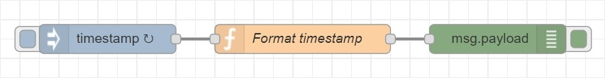

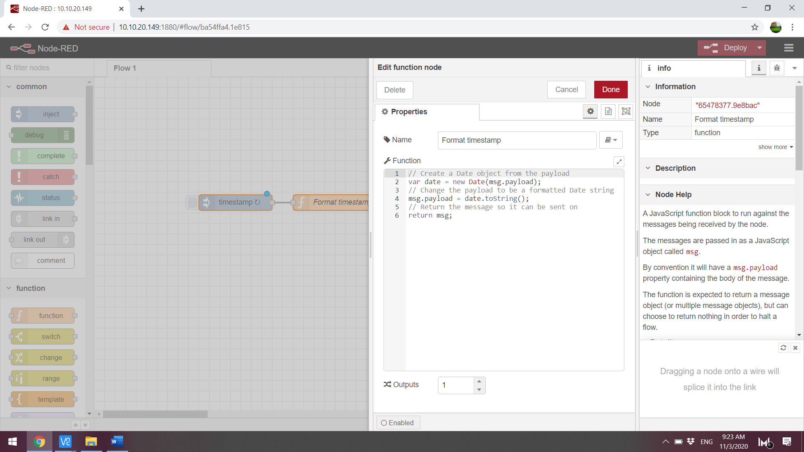

|  |
| --- |
| [{"id":"de377476.2ddbb8","type":"debug","z":"2cd0b7f8.ac84b8","name":"","active":true,"tosidebar":true,"console":false,"tostatus":false,"complete":"payload","targetType":"msg","x":610,"y":260,"wires":[]},{"id":"f53009c5.d86da8","type":"inject","z":"2cd0b7f8.ac84b8","name":"","topic":"","payload":"","payloadType":"date","repeat":"1","crontab":"","once":false,"onceDelay":"","x":210,"y":260,"wires":[["b4e82d40.29a23"]]},{"id":"b4e82d40.29a23","type":"function","z":"2cd0b7f8.ac84b8","name":"Format timestamp","func":"// Create a Date object from the payload\nvar date = new Date(msg.payload);\n// Change the payload to be a formatted Date string\nmsg.payload = date.toString();\n// Return the message so it can be sent on\nreturn msg;","outputs":1,"noerr":0,"x":410,"y":260,"wires":[["de377476.2ddbb8"]]}] |